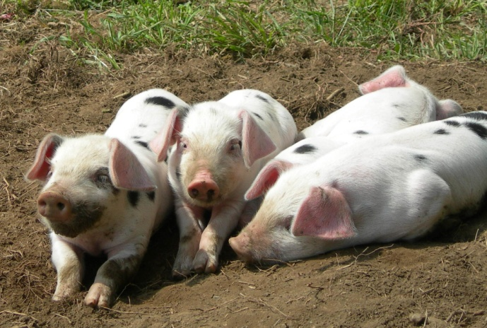In one part of a larger study an investigator raised 64 pigs in the manner described below. The design is modified from the original, but is consistent with the table presented. There were 32 pens available that were randomly assigned to one of the two sexes and one of two dietary supplements. The diet supplements were either no Chromium picolinate (CrP) added or 200 ppb CrP added to a standard corn-soybean meal diet. Note that there were four combinations of sex and diet (male at 0 ppb CrP, female at 0 ppb CrP, male at 200 ppb CrP, female at 200 ppb CrP). For each combination of sex and diet there were eight pens and two pigs randomly assigned to each pen.

At the end of the experiment the final weight was recorded for each pen and daily weight gain calculated as a single value for each of the 32 pens [(final pen weight – initial pen weight) / days]. At the end of the experiment the variable of interest was the mean weight gain for each treatment.

Table 1. Least squares means of chromium picolinate × sex effects on growth performance in pigs.

|  |  |  |  |  |  |  |
| --- | --- | --- | --- | --- | --- | --- |
| Variables & Treatments | Treatments | | | |  |  |
| Supplement → | 0 ppb CrP | | 200 ppb CrP | |  |  |
| Sex → | Barrows | Gilts | Barrows | Gilts | SEM | P–Value |
| Final wt, kgb | 111.8 | 103.9 | 110.6 | 102.9 | 1.0 | 0.90 |
| Daily gain, g/day | 895.5 | 810.4 | 884.0 | 802.0 | 11.4 | 0.90 |
| Feed intake, g/day | 2749.7 | 2460.6 | 2748.1 | 2421.8 | 33.5 | 0.59 |
| Gain/Feed | 0.33 | 0.33 | 0.32 | 0.33 | 0.004 | 0.48 |

a. Pen means (n = 32).

b. Represents the final average pen weight measured at the farm.

Note: Barrows are male swine and Gilts are female swine.

|  |  |  |  |
| --- | --- | --- | --- |
| Answer choices: | **(A) pigs** | **(B) sexes** | **(C) dietary supplements** |
|  | **(D) pens** | **(E) investigators** | **(F) final weights** |

- - - - - - - - - - - - - - - - - - - - - - - - - - - - - - - - - - - - - - - - - - - - - - - - - - - - - - - - - - - - - - - - - - - - - - - - - - - - - - - - - - - - - - - - - -

Circle the appropriate letter for each question.

1) What is the experimental unit for this experiment? A B C D E F

2) What is the sampling unit for this experiment? A B C D E F

3) What is the dependent variable for this experiment? A B C D E F

4) What is the treatment variable for this experiment? A B C D E F

5) If the design is RBD, what are the blocks? A B C D E F NA

6) Does it seem more likely that the treatments are fixed or random? (A) fixed (B) random

7) What is the treatment arrangement for this experiment? (A) single factor (B) factorial (C) nested

8) What is the experimental design? (A) CRD (B) RBD (C) LSD (D) Split-plot (E) Repeated Measures

9) The degrees of freedom for testing treatment are _______________ .

10) The degrees of freedom for the error used for testing treatments are ____________________ .

Answers Question 01: (1) b, (2) a, (3) a, (4) a, (5) b, (6) d, (7) c & e, (8) NA (9, 10) 3, 28

Treatments = (t–1) = 3 as 1, 1, 1, Exp Error = (t(s–1)) = 28 and Sampling Error (ts(n–1)) = 32,   
CTotal = (tsn–1) = 63.

Internet reference: http://scholar.lib.vt.edu/theses/available/etd-11298-162233/unrestricted/green.pdf, (1/31/03), Brent K. Green , Chapter 3. Halothane Gene, Chromium Picolinate Supplementation, and Sex Effects on Live Animal Performance, Carcass Traits, and Subjective Quality Characteristics in Pigs, Animal and Poultry Sciences, Blacksburg, Virginia, February 12, 1997.